**SUPPLEMENTARY FIGURE S2: Maternal health outcome correlations**

Correlation matrix showing relationships between nine maternal health outcomes

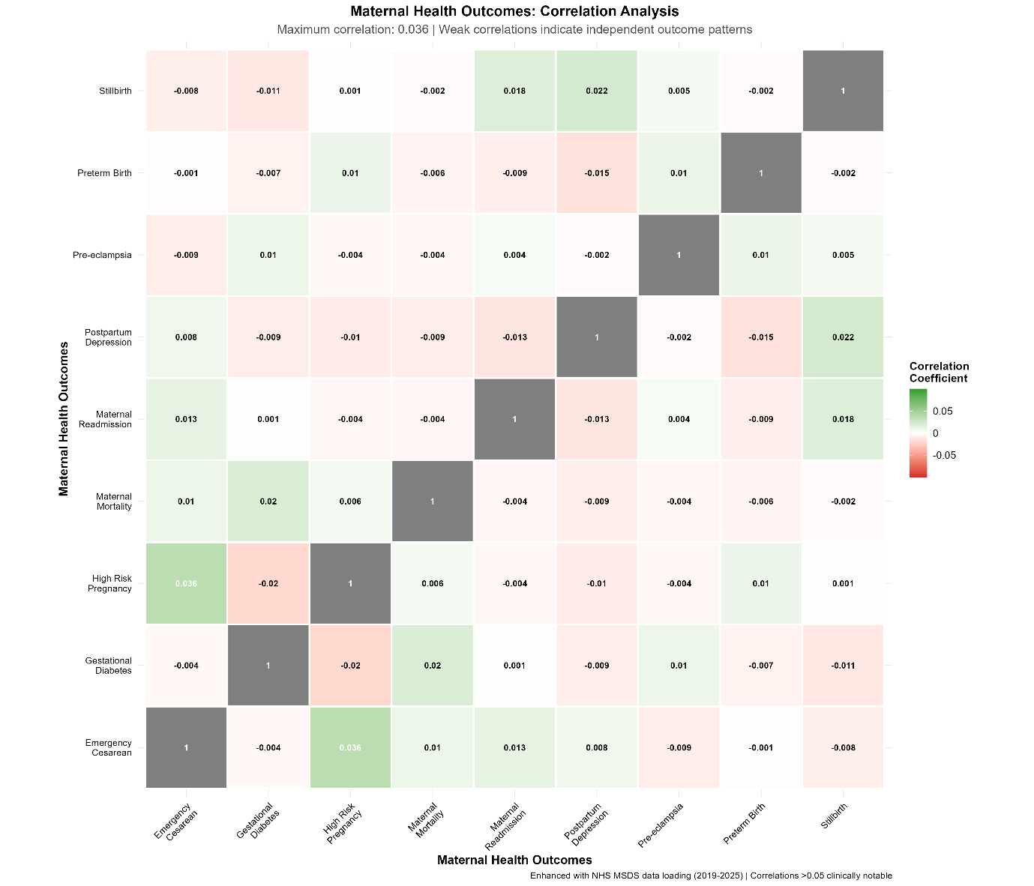

Correlation analysis of maternal health outcomes demonstrating weak correlations (maximum 0.036), confirming that different outcomes represent distinct clinical entities rather than manifestations of a single underlying condition. Enhanced with NHS MSDS data patterns(2019 -2025)